**The Pioneer Players** **(1911-25)**

Led by director Edith Craig, with her mother Ellen Terry as president, the Pioneer Players theatre society was founded on 11 May 1911 in London with the aim of staging the play of ideas. As a play-producing subscription society following the model of the much larger Stage Society and earlier New Century and Independent Theatre societies, the Pioneer Players’ innovative productions of controversial drama for its members were deemed to be private and thereby technically evaded the Lord Chamberlain’s licensing powers.

The company’s staging of plays was reliant on resourcefulness and serendipity, making use of loaned theatres and the generosity of dramatists and actors. Usually given a maximum of two performances, the productions became showcases for new talent, as well as occasions to generate debate. After performances of Laurence Housman’s *Pains and Penalties* in 1911 and Christopher St John and Charles Thursby’s *The Coronation* in 1912, the audience was enlisted to join the anti-censorship campaign. Plays such as *Race Suicide* by Hamilton Fyfe (1912), *The Patience of the Sea* by Conal O’Riordan (1914), and *Idle Women* by Magdalen Ponsonby (1914) appealed to a shared sense of humour in mocking fads, earnest radicals, and reformers. The Pioneer Players also organized at least two costume balls.

Modernist in its mode of production, the society was eclectic in its choice of plays, though in the first few years of activity many were concerned with women’s independence and the campaign for women’s suffrage. The issue of votes for women was not always directly mentioned in the plays, but there was often a close engagement with the wider arguments for social reform and feminism that were part of the women’s suffrage movement, for example, equality in work and marriage and the causes and effects of prostitution. The choice of name for the organisation was particularly resonant in this period, signifying courageous innovation by drawing on metaphors of military conquest. The French *pionnier* is a foot soldier who breaks new ground for the following troops. In women’s suffrage publications, ‘pioneer’ was often synonymous with ‘feminist’. A significant number of activists in the Women’s Freedom League, including Edith Craig and Cicely Hamilton, were also at the centre of the Pioneer Players.

The impact of the First World War on theatre was considerable, and it affected theatre societies as subscribers economised and felt uncomfortable about gaining a reputation for frivolity in a time of austerity. The Pioneer Players rose to this challenge by concentrating their energies on the establishment of an art theatre, producing many works in translation, including Nikolai Evreinov’s expressionist play *The Theatre of the Soul* in 1915. Other plays challenged the limits of naturalism, gendering the claustrophobic confines of the domestic interior and even depicting marriage rejection and violence as a relevant and appropriate response by women in the period before enfranchisement. The society was revived in 1925 after a couple of inactive years, encouraged by Sybil Thorndike who starred in *The Verge* by Susan Glaspell.

**List of Works**

*Ellen Terry and Edith Craig Database: A Guide to the Papers from Smallhythe Place*, [www.ellenterryarchive.hull.ac.uk](http://www.ellenterryarchive.hull.ac.uk). (This database is a descriptive catalogue of the National Trust’s Ellen Terry and Edith Craig archive of over 20,000 documents, including photographs, play programmes, playscripts, and related press cuttings held at either the British Library, London or Smallhythe Place, Kent.)

**References and Further Reading**

Cockin, Katharine. (1994) ‘The Pioneer Players: Plays of/with Identity', *Difference in View: Women in Modernism*, ed. Gabriele Griffin, London: Taylor & Francis, 142-54.

----- (1998) *Edith Craig (1869-1947): Dramatic Lives*, London: Cassell.

----- (2001) *Women and Theatre in the Age of Suffrage: The Pioneer Players 1911-25*, Basingstoke: Palgrave.

Chiba, Yoko. (1995) ‘Kori Torahiko and Edith Craig: A Japanese Playwright in London and Toronto’, *Comparative Drama*, 30 (4): 431-51.

Dymkowski, Christine. (1992) ‘Entertaining Ideas: Edy Craig and the Pioneer Players’, *The New Woman and Her Sisters: Feminism and Theatre 1850-1914*, ed. Viv Gardner and Susan Rutherford, Hemel Hempstead: Harvester Wheatsheaf, 221-33.

Fisher, James. (1995) ‘Edy Craig and the Pioneer Players’ Production of Mrs Warren’s Profession’, *Shaw: The Annual of Bernard Shaw Studies*, vol. 15: 37-56.

Holledge, Julie. (1981) *Innocent Flowers: Women in the Edwardian Theatre*, London: Virago.

**Katharine Cockin, University of Hull**

**Recommended Illustrations**

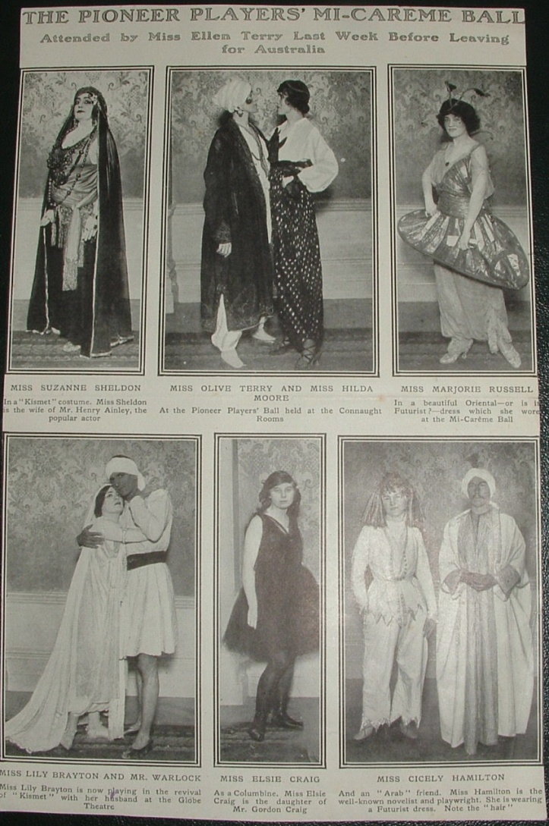

**‘The Pioneer Players’ Mi-carême Ball’, *The Tatler*, 25 March 1914.**

[Contributor Katharine Cockin’s note: “This is my photograph of a press cutting in the Pioneer Players press cuttings album given to me by Raymond Mason and now held in the History Centre, Hull.”]

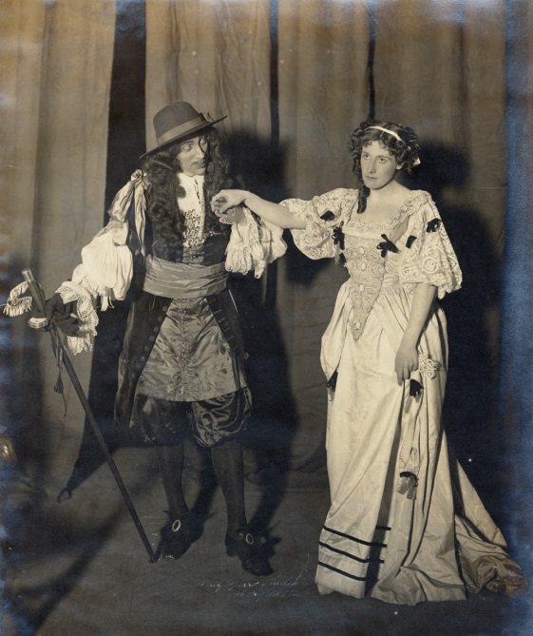

**The Pioneer Players’ production of *The First Actress* by Christopher St. John, Kingsway Theatre, London, 1911.**

[Available at: <http://www.vam.ac.uk/content/articles/p/political-theatre-in-the-early-20th-century/> ]